5 Shoulder Taps Submittal
Setups
- BT DIVERGENCE DOUBLE HOOK

- DEXTER (tight ma’s, consolidation, new 10 period H/L; slope of all ma’s aligned; rvol>1.2;

- ENSEMBLE A:
  - FLIGHT CHECK
  - SAM
  - OPENING PRICE
  - 5 MIN ROC SLOPE
  - 5 MIN VWAP SLOPE
  - 5 MIN EMA SLOPE
  - 5 MIN SMA SLOPE
  - 5 MIN ADX SLOPE
  - RVOL
  - SECTOR IN SYNC
  - # CONSEC DAY MOVE <3
  - 15 OBV ALIGNED
  - TIME OF DAY
  - SLOPE OF VIX

- ENSEMBLE B: SPY SCALP
  - FLIGHT CHECK
  - SAM
  - OPENING PRICE
  - RVOL
  - TIME OF DAY
  - MOV AVG LEVEL 5 MIN TICK
  - MOV AVG SLOPE 5 MIN TICK
  - TEST (LOWER HIGH OR HIGHER LOW IN TICK)
  - HIRO
  - VOL TRACE
  - CANDLE PATTERN
  - GAMMA PROFILE SPX
  - OPEN/CLOSE DATA
  - FIB LEVELS
  - ABOVE / BELOW YESTERDAY’S RANGE
  - SLOPE OF VIX

- ENSEMBLE C: DIVERGENCE (BIG LIST); (RUN ON MORE THAN 1 TIMEFRAME)
  - % ABOVE/BELOW VWAP
  - TRIPLE DIVERGENCE (ONE OF THE FOLLOWING)
    - MACD VS PRICE
    - OBV VS PRICE
  - DOUBLE DIVERGENCE (BOTH OF THE FOLLOWING)
    - MACD VS PRICE
    - OBV VS PRICE
  - TEST
  - RVOL DIV VS RECENT HIGH OR LOW
  - SECTOR
  - REVERSAL CANDLE
  - RVOL INCREASE ON REVERSAL CANDLE

Edge Card: Shoulder Tap 1: BT Divergence (Turn-Confirmed) “Double Hook”
Purpose: Catch the first reliable turn after momentum “lies” (price makes a new extreme, oscillator refuses), then confirms with a second hook.

Timeframe (default): 10-min (works on 5–30m if you keep rules consistent)
Best markets: Liquid index ETFs / mega-caps (SPY/QQQ, TSLA/NVDA, etc.)
Indicator: Essentially a Stochastic indicator (Our BT oscillator) + pivots/swing points

Setup
Long setup
- Market pushing down (at least a local downswing).
- Price makes a lower low vs the prior swing low.
- Oscillator makes a higher low vs its prior swing low (bullish divergence). Secondarily, divergence occurs at/near a meaningful area: prior day low / weekly level / VWAP band / prior demand zone.
Short setup
- Market has been pushing up (local upswing).
- Price makes a higher high vs the prior swing high.
- Oscillator makes a lower high vs its prior swing high (bearish divergence). Secondarily, divergence occurs at/near a meaningful area: prior day high / weekly level / VWAP band / prior supply zone.

2) Definitions
- Hook: Oscillator turns direction after being stretched (e.g., down → up for longs).
- Double Hook: Two distinct oscillator turns in the same direction after the divergence forms.
- Turn-Confirmed: Price confirms the turn (not just oscillator) via a simple structure break.

Trigger (the “do it now” event)
Long Trigger = Double Hook + Turn-Confirm
You have bullish divergence AND:
- Hook #1: Oscillator turns up from a low/stretched zone, then
- Hook #2: Oscillator dips again but holds above its prior oscillator low and turns up again, AND
- Turn-Confirm (price): Price closes above the prior bar high or breaks the most recent micro lower-high (a tiny structure break).
Short Trigger = Double Hook + Turn-Confirm
You have bearish divergence AND:
- Hook #1: Oscillator turns down from a high/stretched zone, then
- Hook #2: Oscillator pops again but holds below its prior oscillator high and turns down again, AND
- Turn-Confirm (price): Price closes below the prior bar low or breaks the most recent micro higher-low.
Entry
Default entry (clean + repeatable)
- Enter the close of the second Turn-Confirm bar of oscillator.

5) Invalidation (hard stop)
Long: Stop goes below the most recent price low that created the divergence (or below the “hook #2” price pivot low
Short: Stop goes above the most recent price high that created the divergence (or above the “hook #2” price pivot high).
Rule: If invalidation hits, you’re out.

Management
We’re not embracing BT Divergence (Double Hook / Turn-Confirmed) as a full strategy yet. Right now, it’s an indicator, a shoulder tap that says:
“Pay attention: a turn may be setting up.” Its entry is relatively specific, but position management is not formalized yet.
It does not include a single, defined entry + stop + exit rule-set. Ultimately other parameters will impact taking or not taking the signals which at this point are not included in the setup.
For now: log the signal, note context (level/regime), and decide whether you’ll take it or ignore it. Later (optional): we can test and choose one clean management/exit framework, like:
- Structure-based targets/stops (swings, VWAP, prior day levels)
- R-multiple plan (e.g., partial at X R, trail the rest)
- Time-based stop (if it doesn’t move quickly, it’s probably not “the one”)

No-Trade Filters
- Time of Day: No trades between 9-11 am PT.
- Oscillator above 30 or below 70 (diminished risk reward). Divergence far from levels: If it’s floating in the middle of nowhere, pass.
- Major news imminently: CPI/Fed/earnings in the specific name or sector
- Huge trend freight train: Defer from trading the oscillator under these circumstances. Define by: SMA Slope; ADX Slope, Rate of Change slope; Flight Check or Sam (internal models) above 10 or below -10, skip.
Notes (common failure mode)
If Hook #2 forms but price cannot break structure (no Turn-Confirm), that’s usually not a tradeable turn, it’s just the market catching its breath before continuing.

Code
Current code (Easy Language for the BT Divergence (Turn-Confirmed) “Double Hook on TradeStation) is in Appendix.

Pattern Examples:

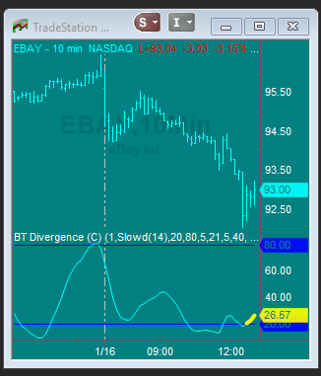
BT Divergence on Chart (bullish)

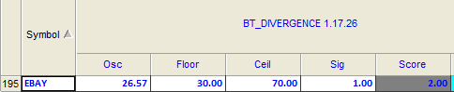
BT Divergence on Radarscreen

(Note: Sig = 1, therefore valid signal; Score = 2 therefore better than a lower score)

DAL (10-min)
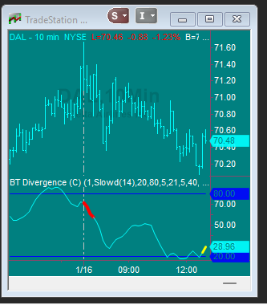
BT Divergence on Chart (bullish)

Bearish Setups

KLAC (10-min)
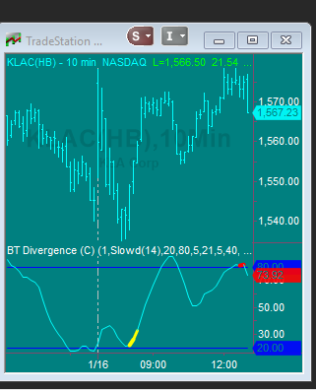
BT Divergence on Chart (bearish)

GLW (10-MIN)
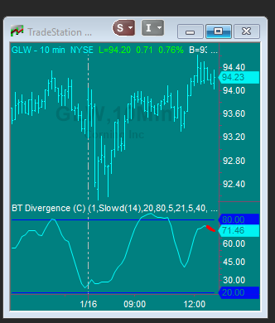
BT Divergence on Chart (bearish)

EA (10-MIN)
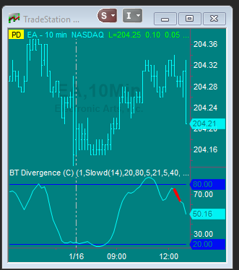
BT Divergence on Chart (bearish)
FALSE POSITIVES
BXP (10-MIN)
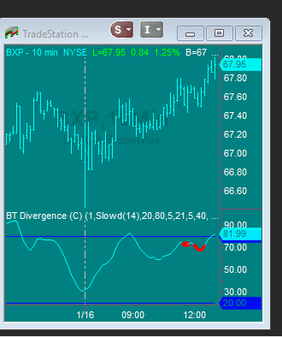
No Signal

DTE (10-MIN)
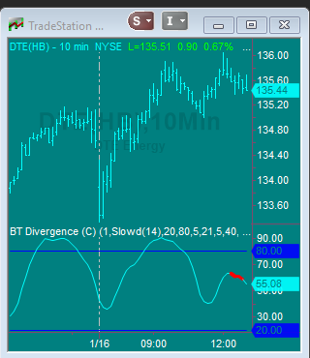
No Signal

NWSA (10-MIN)

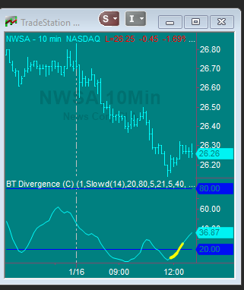
No Signal

Edge Card: Shoulder Tap 2: DEXTER

Purpose

Flag high-probability continuation breakouts/breakdowns when trend is aligned, price is coiled, and time-of-day volume is elevated.
Note: This is a shoulder tap that can function as a strategy.
Timeframe / Universe
- 10-minute bars
- Liquid single names + major ETFs
Setup (all must be true)
1) Trend alignment (20/50 MA stack + slope)
- MA20 = SMA(Close, 20)
- MA50 = SMA(Close, 50)
- Slope(MA) = MA − MA[1]
Bull regime
- MA20 > MA50
- Slope(MA20) > 0 and Slope(MA50) > 0
Bear regime
- MA20 < MA50
- Slope(MA20) < 0 and Slope(MA50) < 0
2) Compression / coil
- Compression = ATR(N) / Close ≤ ATR_a threshold
(Alternative: N-bar range compression.)
3) Breakout / breakdown condition (10-bar extreme)
Bull
- Close > Highest(High, 10)[1]
Bear
- Close < Lowest(Low, 10)[1]
4) Time-of-Day RVOL gate (40-day baseline per 10-min slot)
- RVOL_TOD = CurrentVolume / AvgVol_TOD_40
- Gate: RVOL_TOD ≥ 1.2
Trigger (when the shoulder tap fires)
DEXTER Bull fires when, on the bar:
- Bull regime true
- Compression true
- Bull breakout true
- RVOL_TOD ≥ 1.2
DEXTER Bear fires when, on the bar:
- Bear regime true
- Compression true
- Bear breakdown true
- RVOL_TOD ≥ 1.2
Action (operator-facing)
- Bull: “Aligned-trend breakout + TOD volume expansion. Pull chart → check level/liquidity → decide.”
- Bear: “Aligned-trend breakdown + TOD volume expansion. Pull chart → check level/liquidity → decide.”
Invalidation
- Bull: closes back inside the consolidation range within X bars
- Bear: same, opposite direction
Telemetry (log at alert time)
- MA20, MA50, Slope(MA20), Slope(MA50)
- Compression value (ATR/Close or RangePct)
- Prior 10-bar high/low level
- RVOL_TOD and AvgVol_TOD_40
- Forward returns (1/3/6 bars) or MAE/MFE proxy

Data Sources (Currently monitor on Tradestation)
- OHLCV 10-minute bars
- Precomputed RVOL_TOD series (TradeStation): current volume vs 40-day avg volume for same 10-min slot

- RVOL_TOD = CurrentVolume / AvgVol_TOD_40
Gate:
- RVOL_TOD >= 1.2 (≥120% of normal for that exact time-of-day)

Code
- Current code (Easy Language for the DEXTER on TradeStation) is in Appendix.

Pattern Examples:

- Clean Bull: coil + MA alignment + breakout + RVOL_TOD >= 1.2
- Clean Bear: same in reverse
- False breakout example

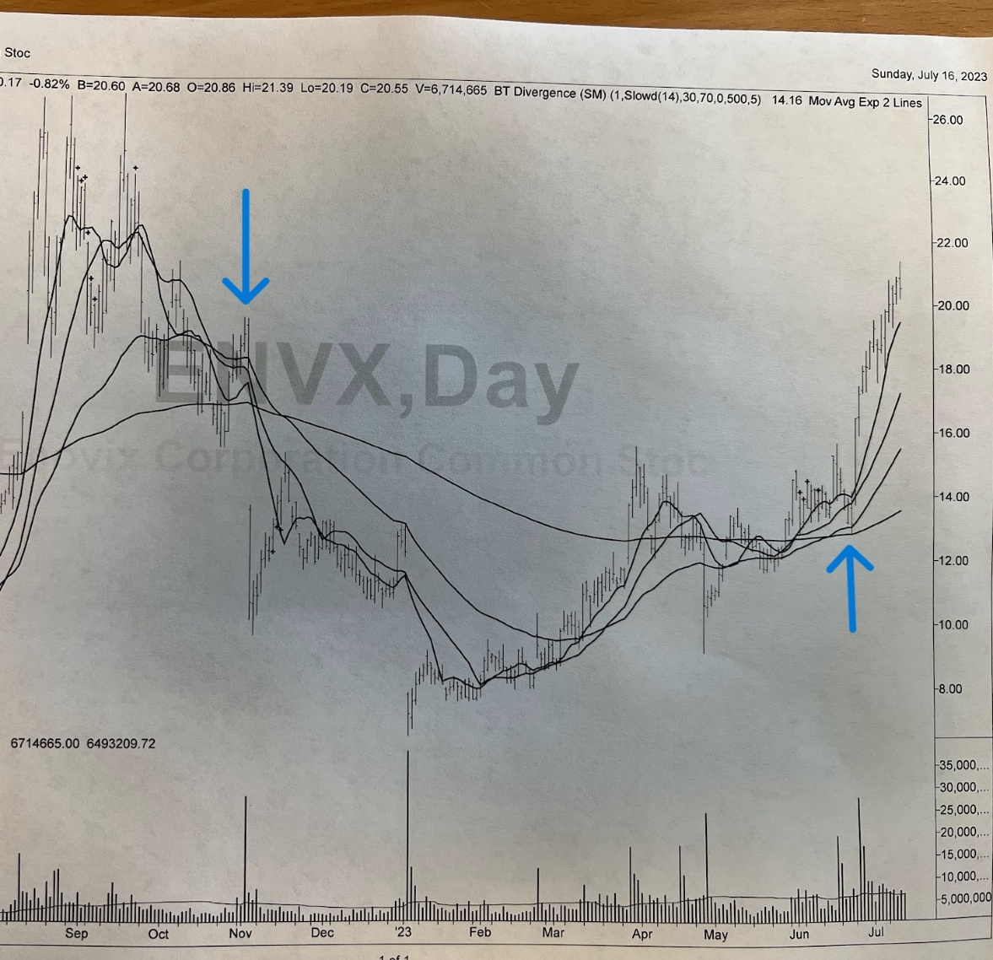
Clean Bear Signal late October; Clean Bull Signal late June

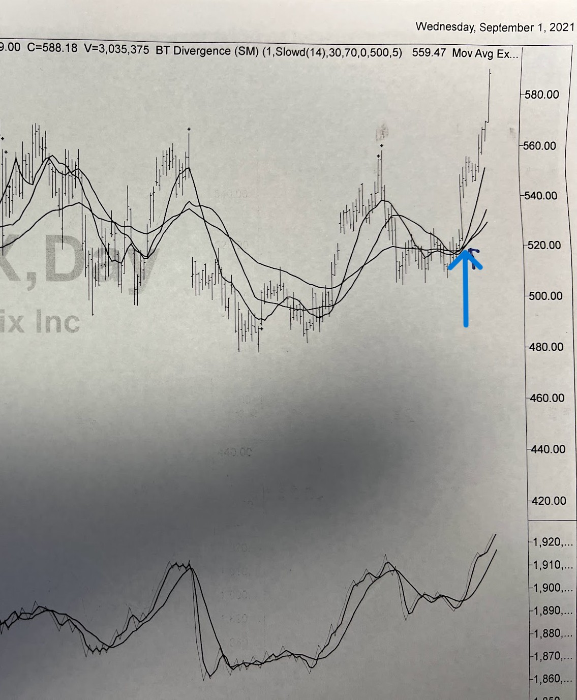
Clean Bull signal

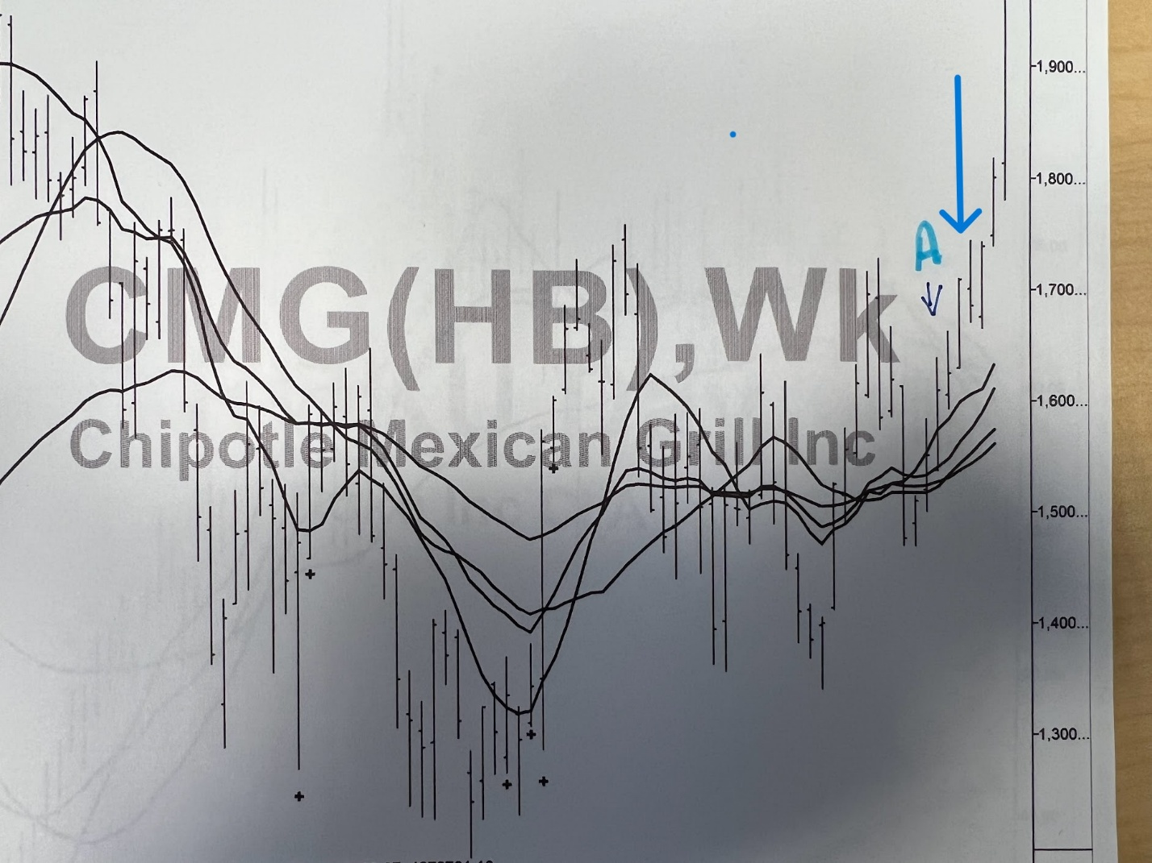
Clean Bull Signal
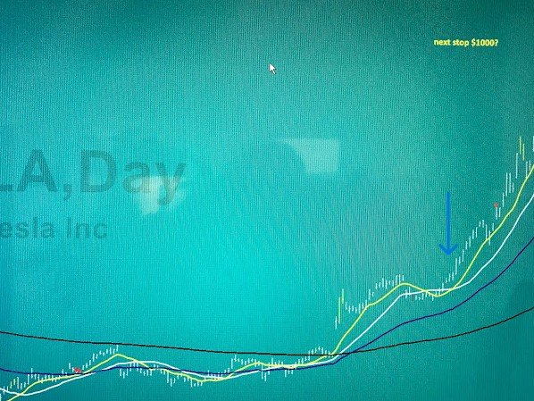

Clean Bull signal

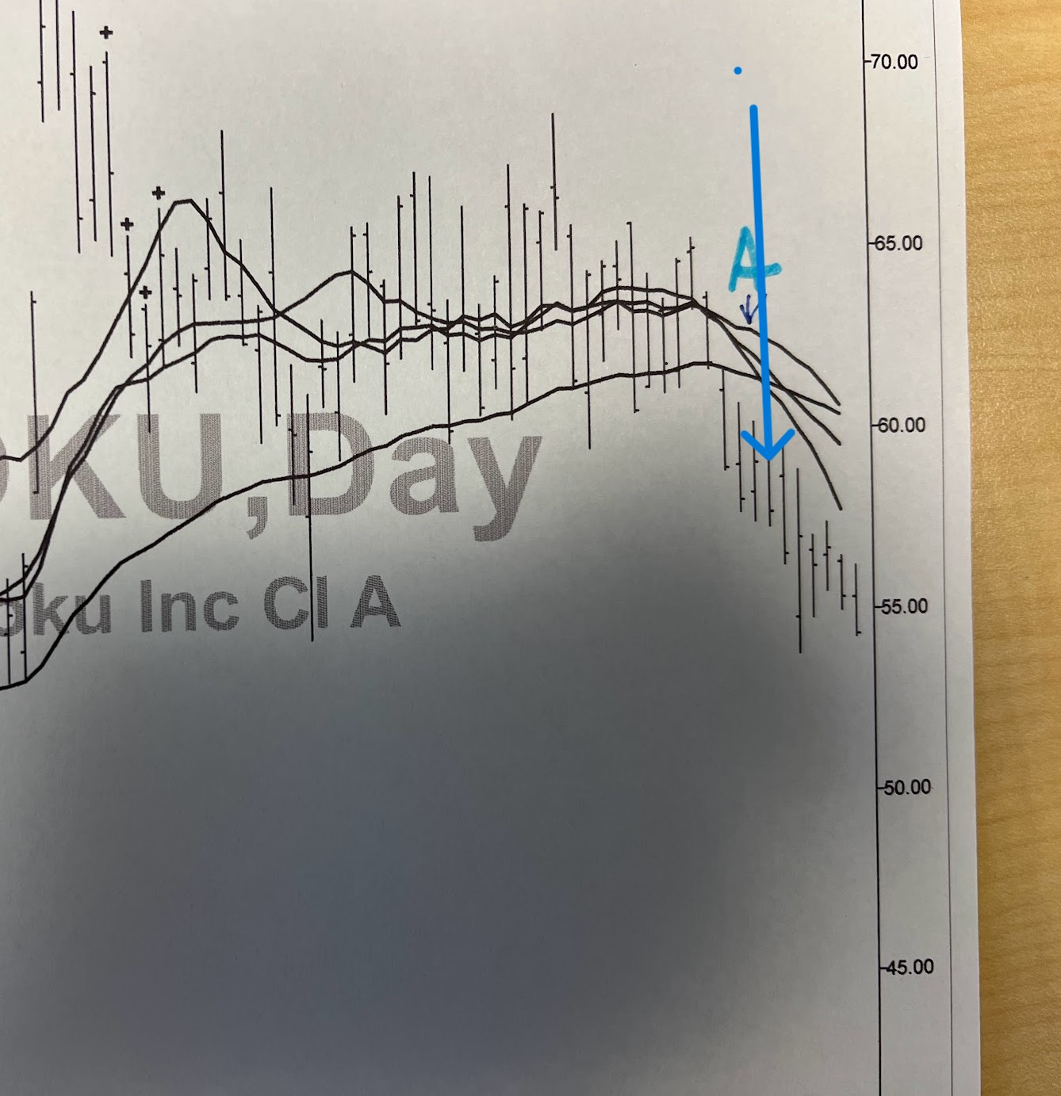
Clean Bear Signal

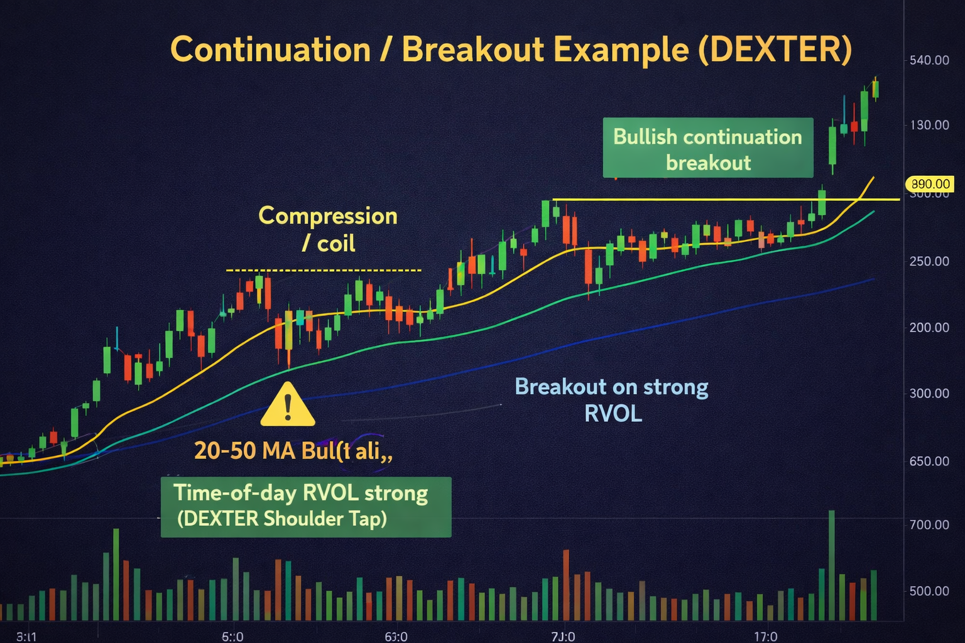

One false breakout (adds credibility fast)

Edge Card: Shoulder Tap 3 — ENSEMBLE A (Momentum Confluence)
Purpose
A shoulder tap for high-momentum intraday trades when price acceleration and market internals agree (Flight Check + SAM), with context filters to reduce false positives.
Note: This is an indicator, not a complete strategy (no fixed entry/stop/exit yet).
Timeframe / Universe
- 5-minute bars
- Liquid single names + major ETFs (best in higher-vol names)

Setup (all gates must pass)
1) Momentum gate — SMA(5) slope is strong and accelerating
On 5-min bars:
- SMA = Average(Close, 5)
- Slope% = ((SMA - SMA[1]) / SMA[1]) * 100
Bull momentum
- Slope% ≥ +0.20
- Slope% > Slope%[1] (accelerating up)
Bear momentum
- Slope% ≤ −0.20
- Slope% < Slope%[1] (accelerating down / more negative)

2) Internals confluence gate — Flight Check + SAM agree with strength
Each model outputs an integer −12 to +12.
Bull internals
- Flight Check ≥ +3
- SAM ≥ +3
Bear internals
- Flight Check ≤ −3
- SAM ≤ −3

3) Participation gate — RVOL
- RVOL ≥ 1.10

4) Vol regime gate — VIX slope sign (15-min, lookback 10)
Compute VIX slope on 15-min bars using a 10-bar lookback (sign only).
- Bull: VIX slope negative
- Bear: VIX slope positive
(Implementation can be as simple as VIX_Close − VIX_Close[10], or a 10-bar regression slope — you only care about sign.)

5) Sector alignment gate — sector ETF move vs prior day close
Determine the symbol’s sector proxy (e.g., XLK tech, SMH semis, XLF financials, etc.).
Compute:
- Sector% = (SectorLast − PriorDayClose) / PriorDayClose * 100
Bull: Sector% ≥ +0.50%
Bear: Sector% ≤ −0.50%

6) Time-of-day gate
- No signals / no trades between 9:00–11:00 AM Pacific

7) VWAP check (operator default)
- Bull: price > VWAP
- Bear: price < VWAP
Recommendation: keep VWAP as a required chart check (not necessarily a hard-coded gate) unless you want the alert count lower.

Trigger (when the shoulder tap fires)
ENSEMBLE A Long fires when, on the 5-min bar:
- Momentum bull: Slope% ≥ +0.20 and Slope% > Slope%[1]
- Flight Check ≥ +3 and SAM ≥ +3
- RVOL ≥ 1.10
- VIX slope (10 period on 15 min bar) is negative
- Sector% ≥ +0.50% (vs prior day close)
- Time outside 9:00–11:00 AM PT
- Operator confirms price > VWAP
- Realistically, the most sensitive parameter is the SMA(5) slope; that will serve as trigger.
ENSEMBLE A Short fires when, on the 5-min bar:
- Momentum bear: Slope% ≤ −0.20 and Slope% < Slope%[1]
- Flight Check ≤ −3 and SAM ≤ −3
- RVOL ≥ 1.10
- VIX slope (10 period on 15 min bar) is positive
- Sector% ≤ −0.50% (vs prior day close)
- Time outside 9:00–11:00 AM PT
- Operator confirms price < VWAP

Action (operator-facing)
- Long: “ENSEMBLE A LONG: SMA(5) slope strong + internals confirm + RVOL + VIX + sector aligned. Check structure + VWAP, then execute.”
- Short: “ENSEMBLE A SHORT: SMA(5) slope strong + internals confirm + RVOL + VIX + sector aligned. Check structure + VWAP, then execute.”

Telemetry (log at alert time)
- SMA(5), Slope%, Slope%[1]
- Flight Check, SAM
- RVOL
- VIX slope sign (10)
- Sector ETF used + Sector% vs prior close
- VWAP relation (above/below)
- Forward returns (1/3/6 bars) and/or MAE/MFE proxy

Data Sources
- 5-min OHLCV (symbol)
- Flight Check + SAM internals feed
- RVOL series
- VIX 5-min series
- Sector ETF 5-min series + prior day close
- VWAP (symbol)

Defaults
- VWAP is a required operator check (not a hard alert gate) so still see taps that are about to reclaim/lose VWAP.
- VIX slope sign: SMA(5) slope on 15 min bar; only care +/−.

Pattern Examples:

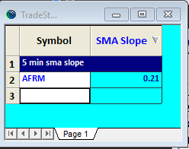
Slope of 10 period simple moving average
on 5 min bar is =>.2 in this instance it reads
+.21
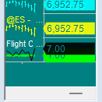
Flight Check reading is >= +3;
here it reads 7
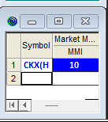
Sam internal mode is >=+3;
here it reads 10

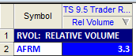
Relative Volume (at this time of day
versus average past 50 days is > 1.1;
here is reads 3.3 X normal

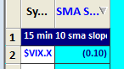
For VIX, Slope of 10 period simple moving average
on 15 min bar is negative; In this instance it is -.1

Sector up > .5% here
Corresponding sector is up
1.8%

VWAP
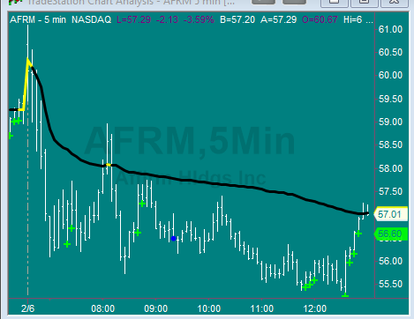
Bull: price > VWAP (technically in this instance
it is right at VWAP)

Edge Card: Shoulder Tap 4 — ENSEMBLE B (SPY Scalp)
TICK Structure + TICK SMA Slope + HIRO SMA Slope + Vol Trace Direction + Internals Regime
Purpose
Identify low-risk SPY scalp moments by spotting a TICK exhaustion/reversal “test” and requiring confluence from HIRO, Vol Trace, and internals regime.
Timeframe / Universe
- Universe: SPY (execution)
- Signal engine: NYSE TICK (1-minute bars) for the test pattern
- HIRO: 1-minute series with SMA(20) slope
- Vol Trace: LiveVol series with a simple 10-minute direction rule
- Internals: Flight Check + SAM

Setup (all gates must pass)
1) Primary trigger — TICK “test” structure (1-minute)
We define structure by two “tests” close together.
Test zones
- Bull test zone: TICK ≤ −200
- Bear test zone: TICK ≥ +200
Sequence window
- Second test must occur 4–12 minutes after the first test.
Bull structure = Higher Low (HL)
- Test1: TICK ≤ −200
- Test2 (4–12 mins later): TICK ≤ −200 again but less negative than Test1
  - Example: −520 then −260 ⇒ bull HL
Bear structure = Lower High (LH)
- Test1: TICK ≥ +200
- Test2 (4–12 mins later): TICK ≥ +200 again but less positive than Test1
  - Example: +680 then +340 ⇒ bear LH

2) TICK momentum confirmation — SMA(20) slope on 5-minute TICK
- Chart: 5-minute TICK
- SMA20 = Average(TICK, 20)
- Gate is slope direction:
Bull confirm: SMA20 slope turning up
Bear confirm: SMA20 slope turning down
(Optional quality boost stays the same if you still want it: better longs when SMA20 starts ≤ −200; better shorts when SMA20 starts ≥ +200.)

3) HIRO slope gate (SpotGamma → SMA slope on 1-min)
On 1-minute HIRO:
- HIRO_SMA20 = Average(HIRO, 20)
- HIRO slope = sign of (HIRO_SMA20 − HIRO_SMA20[1]) (or equivalent)
Bull: HIRO SMA(20) slope positive
Bear: HIRO SMA(20) slope negative

4) Vol Trace direction gate (LiveVol, 10-minute compare)
Define direction using a simple lookback:
- VolTrace_Change = VolTrace_now − VolTrace_10min_ago
Bull: VolTrace_Change < 0 (falling vs 10 minutes ago)
Bear: VolTrace_Change > 0 (rising vs 10 minutes ago)

5) Internals regime gate — Flight Check + SAM (direction permission)
Let FC = Flight Check, SAM = SAM.
- If FC between (−5, +5) AND SAM between (−5, +5) → allow BOTH long + short scalps.
- If FC ≤ −5 OR SAM ≤ −5 → allow ONLY SHORT scalps.
- If FC ≥ +5 OR SAM ≥ +5 → allow ONLY LONG scalps.

Trigger (when the shoulder tap fires)
ENSEMBLE B LONG fires when:
- 1-min TICK prints two ≤ −200 tests 4–12 minutes apart, and Test2 is less negative (HL)
- 5-min TICK SMA20 slope turning up
- 1-min HIRO SMA20 slope positive
- Vol Trace is down vs 10 min ago
- Internals regime permits longs
ENSEMBLE B SHORT fires when:
- 1-min TICK prints two ≥ +200 tests 4–12 minutes apart, and Test2 is less positive (LH)
- 5-min TICK SMA20 slope turning down
- 1-min HIRO SMA20 slope negative
- Vol Trace is up vs 10 min ago
- Internals regime permits shorts

Action (operator-facing)
- LONG: “TICK HL test + confluence. Consider SPY long scalp (tight risk).”
- SHORT: “TICK LH test + confluence. Consider SPY short scalp (tight risk).”

Telemetry (log at alert time)
- TICK Test1 value/time, Test2 value/time, minutes apart, HL/LH flag
- 5-min TICK SMA20 + slope sign
- 1-min HIRO SMA20 + slope sign
- Vol Trace now, Vol Trace 10-min ago, direction sign
- FC + SAM values + regime state
- SPY outcomes: forward returns (1/3/6 bars) + MAE/MFE proxy

Pattern Examples: Edge Card: Shoulder Tap 4 — ENSEMBLE B (SPY Scalp)

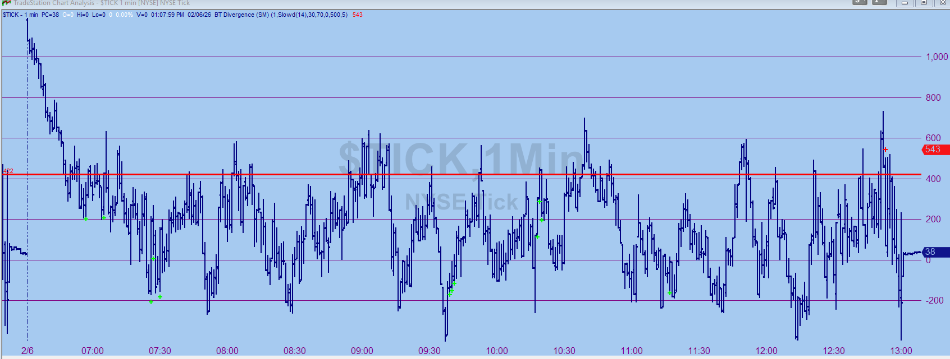
1 MIN TICK CHART

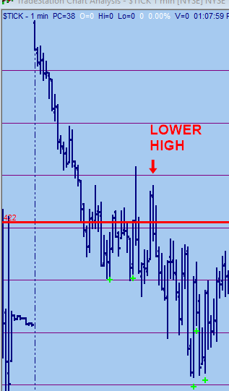
NEGATIVE

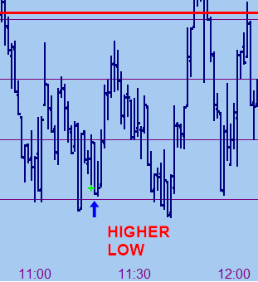
POSITIVE

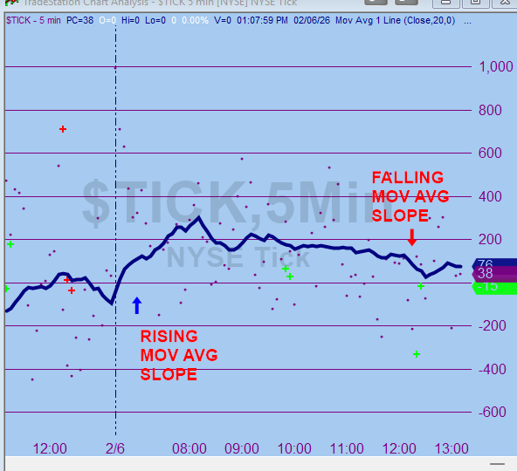
SLOPE OF 5 MIN MOV AVG

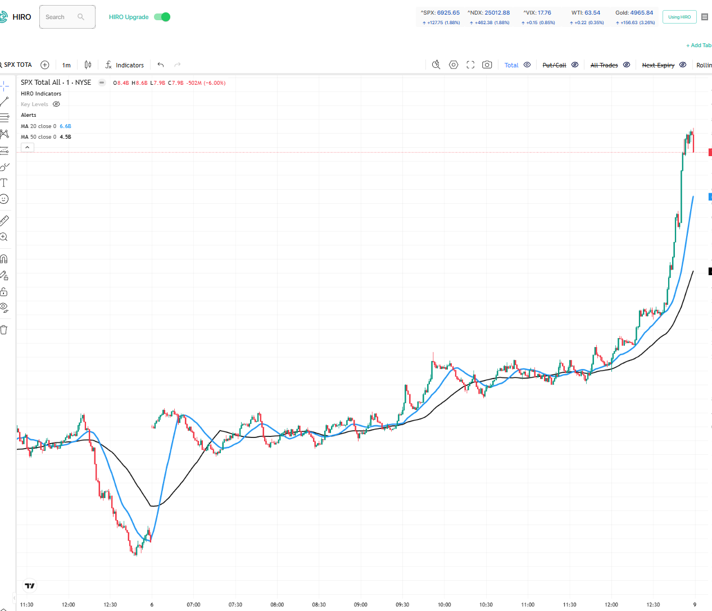
HIRO: AND SLOPE OF 20 PERIOD MA ON 1 MIN HIRO CHART

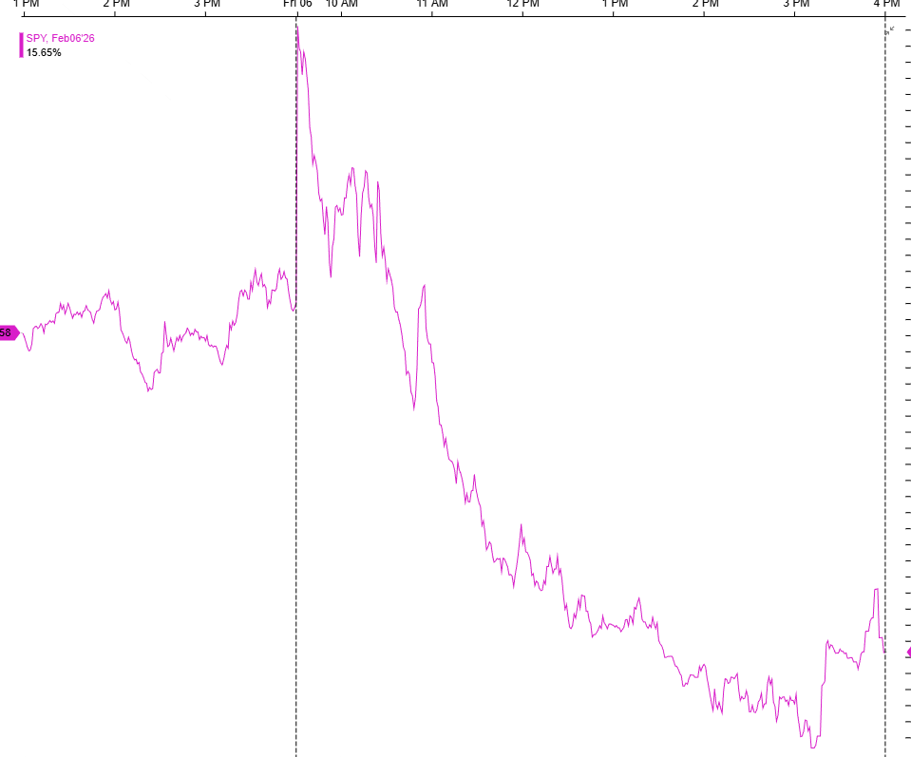
I MIN VOL TRACE CHART:

Edge Card: Shoulder Tap 5 — ENSEMBLE C (BT Divergence Reversal)
BT Divergence vs Price + VWAP Stretch (Extreme) + Reversal Candle + RVOL Spike (5m + 15m)
Purpose
Flag high-quality intraday reversals when:
- BT Divergence disagrees with price (HL/LH vs price),
- price is stretched from VWAP (using extremes),
- a reversal candle prints, and
- the reversal bar shows material volume expansion.
Indicator only (candidate generator) — trade management comes later.
Timeframe / Universe
- Liquid names + major ETFs
- Runs on 5-min and 15-min
  - Alert if either triggers
  - Special alert if both trigger (Option C: same session, same direction)

Setup (all gates must pass)
1) Primary trigger — BT Divergence vs price
Use your BT Divergence gating as the momentum leg:
Bull divergence present when
- BT score ≥ MinScore AND HookOsc ≤ BullHookMax, and
- Price makes a lower low vs prior swing low, while BT oscillator makes a higher low vs prior BT swing low.
Bear divergence present when
- BT score ≤ −MinScore AND HookOsc ≥ BearHookMin, and
- Price makes a higher high vs prior swing high, while BT oscillator makes a lower high vs prior BT swing high.

2) VWAP stretch gate — extreme-based
Compute VWAP stretch using bar extremes:
- Bull stretch: PctFromVWAP_Low = (Low − VWAP) / VWAP × 100
Require: PctFromVWAP_Low ≤ −1.0%
- Bear stretch: PctFromVWAP_High = (High − VWAP) / VWAP × 100
Require: PctFromVWAP_High ≥ +1.0%
(We keep ±1.0% fixed for now; can later make it volatility-adaptive if needed.)

3) Reversal candle gate — small pattern library
Allowed patterns:
Bull reversal candle
- Bullish engulfing, OR
- Hammer, OR
- Long lower wick + strong close (rule-based)
Bear reversal candle
- Bearish engulfing, OR
- Shooting star, OR
- Long upper wick + weak close (rule-based)

4) Volume confirmation — RVOL surge
- RVOL_20 = CurrentBarVolume / Average(Volume, 20)
- Require: RVOL_20 ≥ 1.3
(No time-of-day filter for now.)

Trigger (when the shoulder tap fires)
ENSEMBLE C Bull fires (on a timeframe) when, on the bar:
- Bull BT divergence present
- Low is ≥1% below VWAP (PctFromVWAP_Low ≤ −1.0%)
- Bull reversal candle prints
- RVOL_20 ≥ 1.3
ENSEMBLE C Bear fires (on a timeframe) when, on the bar:
- Bear BT divergence present
- High is ≥1% above VWAP (PctFromVWAP_High ≥ +1.0%)
- Bear reversal candle prints
- RVOL_20 ≥ 1.3

Multi-timeframe alerting
- Single alert: fires if 5-min OR 15-min triggers.
- Special alert (“double-confirm”): fires if both 5-min AND 15-min trigger in the same session and same direction.

Action (operator-facing)
- Bull: “BT divergence + VWAP stretch (extreme) + reversal candle + RVOL spike. Consider long reversal with defined risk.”
- Bear: “BT divergence + VWAP stretch (extreme) + reversal candle + RVOL spike. Consider short reversal with defined risk.”
- Double-confirm: “Both 5m + 15m aligned this session — higher conviction reversal candidate.”

Telemetry (log at alert time)
- Timeframe (5m/15m) + direction
- BT score + HookOsc at signal
- Price pivot points + BT pivot points used
- PctFromVWAP_Low or PctFromVWAP_High
- Candle pattern ID
- RVOL_20 + raw volume
- Outcome scoring: forward returns (1/3/6 bars) + MAE/MFE proxy

Pattern Examples: Edge Card: Shoulder Tap 5 — ENSEMBLE C (BT Divergence Reversal)

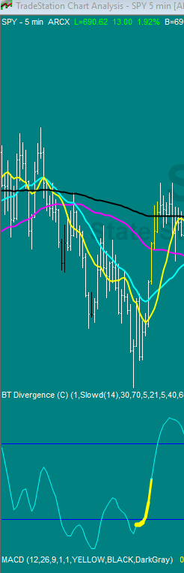
POSITIVE DIVERGENCE

